A.**Simple calculator using servlet**

**STEP 1 : CREATE PROJECT >>>> JAVA WEB >>>>WEB APPLICATION >>> FINISHED**

**STEP 2 : PASTE BELOW CODE IN index.html in <body>**

**<form action="Calculator" method="get" name="frm">**

**Enter num1:**

**<input name="txt1" type="text" />**

**<br>**

**Enter num2:**

**<input name="txt2" type="text" />**

**<br>**

**Operator**

**<select name="op">**

**<option value="Addition">Addition</option>**

**<option value="Subtraction">Subtraction</option>**

**<option value="multiplication">multiplication</option>**

**<option value="division">division</option>**

**</select>**

**<br>**

**<input type="submit" value="submit" />**

**</form>**

**STEP 3 : CREATE SERVLET >>> RIGHT CLICK ON PROJECT >>> NEW >>> SERVLET >>> NAME >>> Calculator.java**

**PASTE THE CODE**



**OUTPUT :** 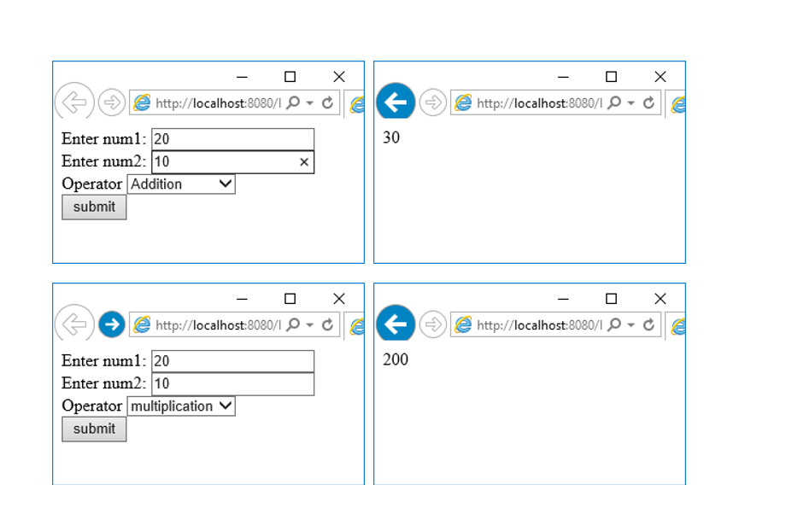

**YOUTUBE LINK**

<https://www.youtube.com/watch?v=1Cox7GDHFLY&list=PLf2Wj8X3RbBS8IbrmdbSTRNDKauvsVZsh&index=1>

**Login page using servlet**

**STEP 1 : CREATE PROJECT >>>> JAVA WEB >>>>WEB APPLICATION >>> FINISHED**

**STEP 2 : PASTE BELOW CODE IN index.html in <body>**



**STEP 3 : CREATE SERVLET >>> RIGHT CLICK ON PROJECT >>> NEW >>> SERVLET >>> NAME>>> Login.java**

package pack;

import java.io.IOException;

import java.io.PrintWriter;

import javax.servlet.ServletException;

import javax.servlet.http.HttpServlet;

import javax.servlet.http.HttpServletRequest;

import javax.servlet.http.HttpServletResponse;

public class Login extends HttpServlet {

@Override

protected void doPost(HttpServletRequest request, HttpServletResponse response)

throws ServletException, IOException {

**PrintWriter out = response.getWriter();**

**String n1 = request.getParameter("txt1");**

**String n2 = request.getParameter("txt2");**

**if(n1.equals("abc") && (n2.equals("abc123"))){**

**out.println("WELCOME " +n1);**

**}**

**else**

**{**

**out.println("INCORRECT USERNAME AND PASSWORD ");**

**}**

}

@Override

public String getServletInfo() {

return "Short description";

}

}

**OUTPUT**

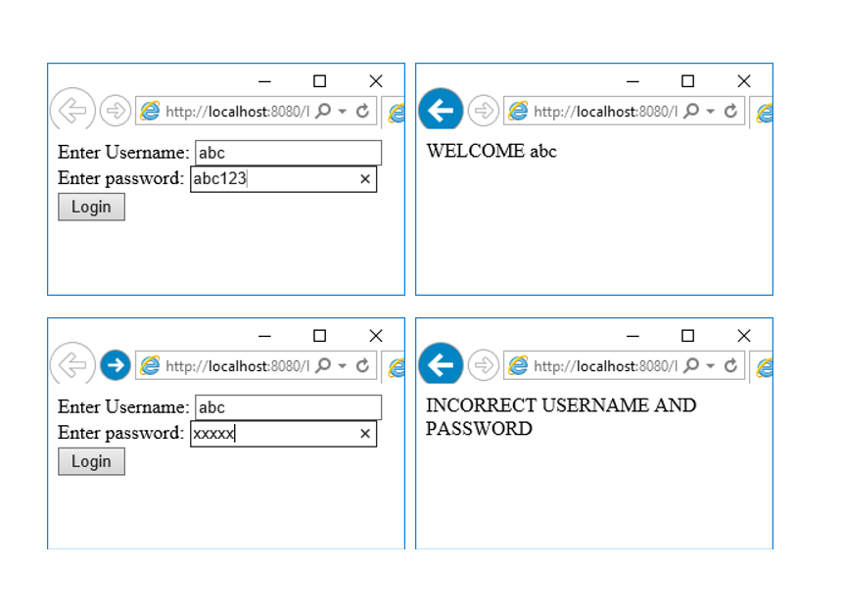**YOUTUBE LINK :** [**https://www.youtube.com/watch?v=Zq-AER4xVzk&list=PLf2Wj8X3RbBS8IbrmdbSTRNDKauvsVZsh&index=2**](https://www.youtube.com/watch?v=Zq-AER4xVzk&list=PLf2Wj8X3RbBS8IbrmdbSTRNDKauvsVZsh&index=2)

**C) Create a registration servlet in Java using JDBC. Accept the details such as Username, Password, Email, and**

**Country from the user using HTML Form and store the registration details in the database.**

**STEP 1 : COMPLATE THE DATA BASE PART >> GO TO SERVICE >>>>**

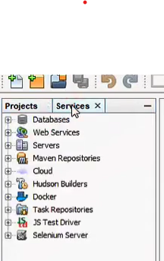

**STEP 2 : CLICK ON DATA BASE >>>>> RIGHT CLICK ON MY SQL >>> CREATE NEW DATA BASE >>>name>>> BSCIT**

**STEP 3 : RIGHT CLICK ON BSC IT AND CLICK ON CONNECT**

**STEP 4 : RIGHT ClLICK ON BSC IT >>> CREATE TABLE >> NAME > TABLE NAME IS :Ragistration >>**

**ADD COLUMN AS PER THE QUESTION AND SELECT TYPE ,SIZE**

**COLUMN SUCH AS USERNAME ,PASSWORD ,EMAIL, CONTARY**

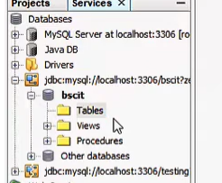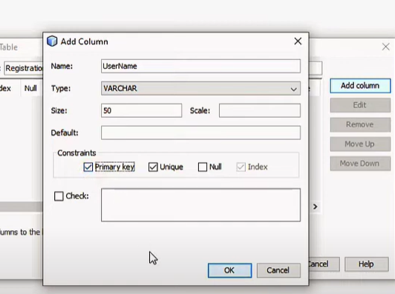

**STEP 4 : RIGHT CLICK ON Registration form >>> VIEW DATA**

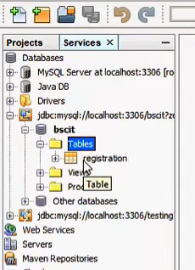

**STEP 4 : GO TO PROJECT >>> CREATE PROJECT >>>> JAVA WEB >>>>WEB APPLICATION >>> FINISHED**

**STEP 5 : PASTE BELOW CODE IN index.html in <body>**

**<form action="RegisterServlet" >**

**<H1>Welcome to Registration page</H1>**

**Enter User Name <input type="text" name="txtUid"><br>**

**Enter Password <input type="password" name="txtPass"><br>**

**Enter Email <input type="text" name="txtEmail" ><br>**

**Enter Country <input type="text" name="txtCon" ><br>**

**<input type="submit" value="REGISTER" >**

**</form>**

**STEP 6: CREATE SERVLET >>> RIGHT CLICK ON PROJECT >>> NEW >>> SERVLET >>> NAME>>> RegisterServlet.java**

package mypack;

import java.io.IOException;

import java.io.PrintWriter;

import javax.servlet.ServletException;

import javax.servlet.http.HttpServlet;

import javax.servlet.http.HttpServletRequest;

import javax.servlet.http.HttpServletResponse;

import java.sql.*;

public class RegisterServlet extends HttpServlet {

@Override

protected void doGet(HttpServletRequest request, HttpServletResponse response)

throws ServletException, IOException {

**response.setContentType("text/html;charset=UTF-8");**

**PrintWriter out = response.getWriter();**

**String id = request.getParameter("txtUid");**

**String ps = request.getParameter("txtPass");**

**String em = request.getParameter("txtEmail");**

**String co = request.getParameter("txtCon");**

**try {**

**Class.forName("com.mysql.jdbc.Driver");**

**Connection con = DriverManager.getConnection("jdbc:mysql://localhost:3306/LoginDB", "root", "root");**

**PreparedStatement pst = con.prepareStatement("insert into user values(?,?,?,?)");**

**pst.setString(1, id);**

**pst.setString(2, ps);**

**pst.setString(3, em);**

**pst.setString(4, co);**

**int row = pst.executeUpdate();**

**out.println("<h1>" + row + " Inserted Succesfullyyyyy");**

**} catch (Exception e) {**

**out.println(e);**

**}**

}

}

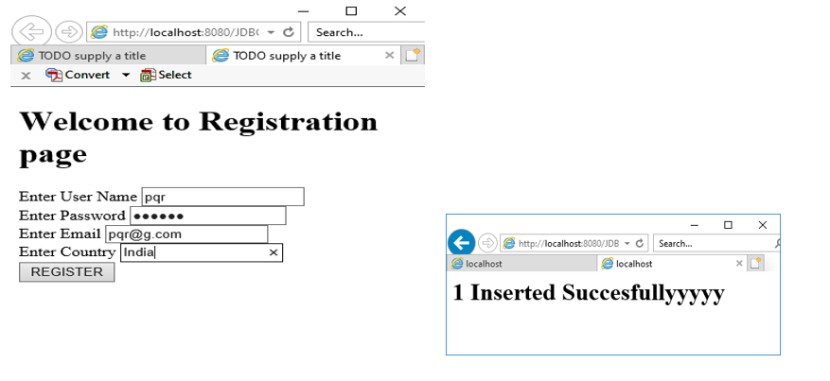

**YOUTUBE LINK :** [**https://www.youtube.com/watch?v=mnyzPM4L7LM&list=PLf2Wj8X3RbBS8IbrmdbSTRNDKauvsVZsh&index=3**](https://www.youtube.com/watch?v=mnyzPM4L7LM&list=PLf2Wj8X3RbBS8IbrmdbSTRNDKauvsVZsh&index=3)